Prediction of Stock Price data Using Polynomial Regression Model
Ammar Junaid, Kashinath J Nair, Tufleuddin Biswas, Lingam Tejeswi Tanya
________________________________________________________________________________
Abstract
The correct prediction of a stock is a very challenging task due to non-linear and volatile nature of financial markets. This study tries to understand the application of polynomial regression models for forecasting stock price ups and downs using market data. Information regarding price is obtained from NASDAQ listings for stocks ADDvantage Technologies (AEY) and LiveNova PLC (LIVN), which is then analyzed to check how higher order regression models can interpret complex market trends that do not have linear relationships. Quadratic and cubic polynomial regression models, with orthogonal and piecewise polynomial models, were analysed and then compared using statistical indicators like root mean square error (RMSE), mean absolutes prediction (MAPE), and multiple coefficients of determination (R²). The obtained results showed that increasing model flexibility improves prediction capability, with cubic and piecewise polynomial models showing more reliable prediction with R² = 0.768, RMSE = 0.262, MAPE = 8.820 and adjusted R² = 0.719. Piecewise or segmented regression particularly demonstrated improved adaptability two variations and changes in stock price. The study concludes that piecewise polynomial regression methods give out a framework that is interpretable and statistically robust for stock price prediction and analysis.
The analysis carried out on the stock data of LiveNova PLC (LIVN) results out the given values R² = 0.943, RMSE = 0.837, MAPE = 34.464 and adjusted R² = 0.718. This shows that the predictive accuracy is decent but percentage deviations are seen.
Introduction
Regression analysis with a statistical technique that is used to determine relationship between one dependent variable and one or more independent variable. The primary objective of regression analysis is the model and numerically show the influence of changes in the predictor variable on the response variable. It helps in understanding and forecasting the strength and direction of relationships between variables.
Regression analysis plays a crucial role in economics, Business Analytics, engineering, Finance and data science. But, in many real life situations the relationship between variables might strictly not be linear all the time and during these scenarios simple linear regression cannot be used. To Address these specific cases, techniques under regression like polynomial and piecewise regression is used for analysis.
Polynomial regression is a sub-branch of linear regression where higher powers of independent variables are also included in the model so that the curvature is taken under consideration.
Piecewise regression, also known as segmented regression, is used when the relationship between variable changes at certain points within the range of the predictor variable. Instead of fitting a single function different regression equations are fitted over different intervals.
Research Background
Regression analysis has been studied and developed for over a century. It is a key part of statistical modeling and quantitative research. Research on regression covers theory, new methods, and practical uses in many fields.
The concept of regression was first introduced by Francis Galton (1886) in his study of heredity, where he observed the phenomenon of “regression toward the mean.” Later, the method of least squares, originally developed by Legendre (1805) and Gauss (1809), provided the mathematical basis for estimating regression parameters.
In the 20th century, the theory of classical linear regression became more formal. The Gauss–Markov theorem showed that, under particular conditions, the ordinary least squares (OLS) estimator is the Best Linear Unbiased Estimator. Draper and Smith (1998) provide a thorough outline of linear regression, focusing on model checks, testing assumptions, and real-world data analysis.
Later research extended linear regression to involve multiple predictors and interaction terms. This made the models even better at explaining data.
When real world data showed linear patterns, research attempted to try to find Ways to linear models the capture. Polynomial regression then became a very commonly used solution by adding higher of predictor variables while keeping the model linear in its parameters.
Early uses of polynomial models were common in physical sciences and engineering, where smooth curves were needed to describe complex relationships. In economics, quadratic cost functions and cubic growth curves became standard tools.
Draper and Smith (1998) covered polynomial regression in detail. They found out problems like multicollinearity among polynomial terms and suggested using orthogonal polynomials to make results easier to interpret. Orthogonal polynomials reduce extend over among predictors, leading to more reliable estimates. Later research found that polynomial models, especially those with high degrees, can easily overfit the data. Overfitting makes models less general and can give misleading results, especially if the extra flexibility does not match the real data pattern. To address this, methods like ridge regression and LASSO were created to limit model complexity by adding penalties. These regularization methods help balance model fit and prediction accuracy, improving polynomial regression by tackling its main weaknesses.
Modern literature compares polynomial regression with nonparametric techniques, noting that while polynomial models are easy to interpret, they may behave poorly near the boundaries of the data range.
Piecewise regression was developed to tackle down situations where relationships change across different regions of the predictor variable. Unlike polynomial regression, which fits a single smooth function globally, piecewise regression allows different linear (or nonlinear) functions in different intervals.
In econometric models, for structural breaks Quandt (1960) and Chow (1960) introduced Statistical tests, Which became the groundwork for Segmented regression techniques. Some developments In the future included spline regression, where continuity constraints were used where the knots are to make sure there is smooth transition between segments.
In public health research, Piecewise regression has been widely used to understand Intervention effects in Interrupted Time Series analysis. Environmental studies have used piecewise models to understand threshold effects in pollution exposure and climate change data.
Recent literature highlights the interpretation powers of piecewise regression over high degree polynomials, especially when there is theory to justify the existence of the structural breaks.
Methodology
This dataset contains historical daily prices for all tickers currently trading on NASDAQ. The up to date list is available from nasdaqtrader.com. The historic data is retrieved from Yahoo finance via yfinance python package. ADDvantage Technologies (AEY) and LiveNova PLC (LIVN) are the stock data that is taken from this dataset.
It contains prices for up to 01 of April 2020.
Kaggle
Date - specifies trading date
Open - opening price
High - maximum price during the day
Low - minimum price during the day
Close - close price adjusted for splits
Adj Close - adjusted close price adjusted for both dividends and splits.
Volume - the number of shares that changed hands during a given day.

Multiple Linear Regression
A method for modeling relationships between variables. It makes it possible to infer or predict a variable based on other variables.
The variable used for prediction are called independent variables and the variable we want to predict is called dependent variable.
$$y=β_{0}+β_{1}x_{1}+β_{2}x_{2}+…+β_{k}x_{k}+ε$$
This model can be expressed as:
$$Y=Xβ+ε$$Where,
$$X=\left[\begin{matrix}1 & x_{11} & x_{12} & ⋯ & x_{1k} \\ 1 & x_{21} & x_{22} & ⋯ & x_{2k} \\ ⋮ & ⋮ & ⋮ & ⋱ & ⋮ \\ 1 & x_{n1} & x_{n2} & ⋯ & x_{nk}\end{matrix}\right]$$
$$Y=\left[\begin{matrix}y_{1} \\ y_{2} \\ ⋮ \\ y_{n}\end{matrix}\right]$$
$$β=\left[\begin{matrix}β_{0} \\ β_{1} \\ ⋮ \\ β_{k}\end{matrix}\right]$$
$$ε=\left[\begin{matrix}ε_{1} \\ ε_{2} \\ ⋮ \\ ε_{n}\end{matrix}\right]$$

Assumptions
- Linear Relationship must exist
- Independence of Error → The error of one point should not affect another.
- Errors should be normally distributed
- No multicollinearity - Two or more independent variables must not be highly correlated with each other.

Polynomial Regression
This a special case of multiple Regression, with only one independent variable. It is expressed as
$$y_{i}=β_{0}+β_{1}x_{i}+β_{2}x_{i}^{2}+β_{3}x_{i}^{3}+…+β_{x}x_{i}^{k}\text{, for }i=1,2…,n$$

$y=β_{0}+β_{1}x+β_{2}x^{2}+ε$ is called second order model in one variance.
In general, $k$th order polynomial in one variance is
$$y=β_{0}+β_{1}x+β_{2}x^{2}+⋯+β_{k}x^{k}+ε$$
Kth order polynomial in one variance is
$$y=β_{0}+β_{1}x_{0}+β_{2}x^{2}+…+β_{k}x^{k}+ε$$
$${Set}_{e}=x^{j}$$
$$y=β_{0}+β_{1}x_{1}+β_{2}x_{2}+…+β_{k}x_{k+ε}$$
Then $k^{\text{th }}$ order polynomial model in one variance because a MLR model with $k$ regressors $x_{1},x_{2},…,x_{k}$

Model Building strategy
Forward Selection: Start with Linear Model
$$y=β_{0}+β_{1}x+ε$$
$$y=β_{0}+β_{1}x+β_{2}x^{2}+ε$$
$$y=β_{0}+β_{1}x+β_{2}x^{2}+β_{3}x^{3}+ε$$

Successively fit model of increasing order unit the $t$ test for the highest order term is non-significant.

Ill-conditioning
As the order of the polynomial increases the $\left(X^{'}X\right)$ matrix becomes ill-conditioned.
Ill-condition means almost singular
$$\overset{ˆ}{B}={\left(X^{'}X\right)}^{-1}X^{'}Y$$
If the values of $x$ are limited to a narrow range, there can be significant ill-conditioning problem in columns of $X$.
$$y=β_{0}+β_{1}x+β_{2}x^{2}+…+β_{k}x^{k}+ε$$
$$X=\left(\begin{matrix}1 & x & x^{2} \\ 1 & 0.11 & 0.121 \\ 1 & 0.12 & 0.144 \\ 1 & 0.13 & 0.169\end{matrix}\right) x^{2}≈0.01*x$$
Centering the data may remove - Ill-conditioning, we fit the model.
$$Y=β_{0}+β_{1}(x-\overset{‾}{x})+β_{2}(x-\overset{‾}{x})^{2}+ε$$
$$Y=β_{0}+β_{1}X +β_{2} x^{2}+ε$$

$\text{Orthogonal Polynomials}$
Suppose we wish to fit the model
$$y=β_{0}+β_{1}x+β_{2}x^{2}+…+β_{k}x^{k}+ε$$
$$X=\left(\begin{matrix}1 & x & x^{2} & x^{k}\end{matrix}\right)$$

If we wish to add another term $β_{k+1},x^{k+1}$, we must recompute ${\left(X^{'}X\right)}^{-1}$ and estimates of lower order parameters ${\overset{ˆ}{β}}_{0},{\overset{ˆ}{β}}_{1},…{\overset{ˆ}{β}}_{k}$ will change
$$X={\left(\begin{matrix}1 & x & x^{2} & x^{k}\end{matrix}\right)}^{x^{k+1}}$$

If we construct polynomials $P_{0}(x),P_{1}(x)$... $P_{k}(x)$ with the property that they are orthogonal polynomials
$$\left.\sum_{i=1}^{n}{ } P_{r}\left(x_{i}\right)P_{s}\left(x_{i}\right)=0, r≠s,r,s=1,α,..,k\right\}$$
We can rewrite the model as,
$$\begin{matrix}y_{i}=α_{0}P_{0}\left(x_{i}\right)+α_{1}P_{1}\left(x_{i}\right)+⋯+α_{k}P_{k}\left(x_{i}\right)+ε_{i} \\ i=(1)n\end{matrix}$$
where $P_{r}\left(x_{i}\right)$ is a $γ$-tn order orthogonal polynomial.
$$P_{0}\left(x_{i}\right)=1$$
$$P_{1}\left(x_{i}\right)=λ_{1}\left(\frac{x_{i}-\overset{‾}{x}}{d}\right)$$
$$P_{2}\left(x_{i}\right)=λ_{2}\left[{\left(\frac{x_{i}-\overset{‾}{x}}{d}\right)}^{2}-\left(\frac{n^{2}-1}{12}\right)\right]$$
$$P_{3}\left(x_{i}\right)=λ_{3}\left[{\left(\frac{x_{i}-\overset{‾}{x}}{d}\right)}^{3}-\left(\frac{x_{i}-\overset{‾}{x}}{d}\right)\left(\frac{3n^{2}-7}{20}\right)\right]$$
$$P_{4}\left(x_{i}\right)=λ_{4}\left[{\left(\frac{x_{i}-\overset{‾}{x}}{d}\right)}^{4}-{\left(\frac{x_{i}-\overset{‾}{x}}{d}\right)}^{2}\left(\frac{3x^{2}-13}{14}\right)+\frac{3\left(x^{2}-1\right)\left(n^{2}-9\right)}{560}\right]$$

$$y=α_{0}P_{0}(x)+α_{1}P_{1}(x)+…+d_{k}P_{k}(x)+ε \\ X=\left(\begin{matrix}1 & P_{1}\left(x_{1}\right) & P_{2}\left(x_{1}\right) & P_{k}\left(x_{1}\right) \\ 1 & P_{1}\left(x_{2}\right) & P_{2}\left(x_{2}\right) & P_{k}\left(x_{2}\right) \\ ⋮ & ⋮ & ⋮ & ⋮ \\ 1 & P_{1}\left(x_{n}\right) & P_{2}\left(x_{n}\right) & P_{k}\left(x_{n}\right) \\ & & & \end{matrix}\right) \\ X^{'}X=\left(\begin{matrix}n & 0 & 0 & … & 0 \\ 0 & ∑_{1}^{n} p_{1}^{2}\left(x_{i}\right) & 0 & … & 0 \\ 0 & 0 & 0 & … & ∑_{1}^{n} p_{k}^{2}\left(x_{i}\right)\end{matrix}\right) \\ Y=Xα+ε$$LSE: $\overset{ˆ}{α}={\left(X^{'}X\right)}^{-1}X^{'}Y, {\overset{ˆ}{α}}_{0}=\frac{∑_{yi}}{n }=\overset{‾}{y}$
$$\begin{matrix}{\overset{ˆ}{α}}_{j} & =\frac{\sum{ }P_{j}\left(x_{i}y_{i}\right)}{\sum{ }P_{j}^{2}\left(x_{i}\right)} j=1,2,..k \\ & \end{matrix}$$
$$SS_{\text{Res }}=∑_{i=1}^{n} e_{i}^{2}=∑_{1}^{n} {\left(y_{i}-{\overset{ˆ}{y}}_{i}\right)}^{2}=(Y-\overset{ˆ}{Y})^{'}(Y-\overset{ˆ}{Y})$$

$$=Y^{'}Y-Y^{'}×\overset{ˆ}{α} MLR$$
$$\begin{matrix} & \\ & =\sum_{i=1}^{n}{ } y_{i}^{2}-\sum_{j=0}^{k}{{\overset{ˆ}{α}}_{j} }\sum{ }y_{i}P_{j}(x_{i})\end{matrix}$$
$$=\sum_{i=1}^{n}{ } y_{i}^{2}-{\overset{ˆ}{α}}_{0}\sum{ }y_{i}-\sum_{j=1}^{k}{{\overset{ˆ}{α}}_{j}} \sum{ }y_{i}P_{j}\left(x_{i}\right)$$
$$=\sum{ }y_{i}^{2}-n{\overset{‾}{y}}^{2}-\sum_{j=1}^{k}{ } {\overset{ˆ}{α}}_{j}\sum_{i=1}^{n}{ } P_{j}\left(x_{i}\right)$$
$$=SS_{T}-\sum_{j=1}^{k}{ } {\overset{ˆ}{α}}_{j}\sum_{i=1}^{n}{ } y_{i}P_{j}\left(x_{i}\right)$$
$$SS_{\text{reg }}=\sum_{j=1}^{k}{ } {\overset{ˆ}{α}}_{j}\sum_{i=1}^{n}{ } y_{i}P_{j}\left(x_{i}\right)$$
$$SS_{\text{reg }}\left(α_{j}\right)={\overset{ˆ}{α}}_{j}\sum_{i=1}^{n}{ } y_{i}P_{j}\left(x_{i}\right)$$

All sum of squares for $α_{1},d2,…,dk$ are orthogonal and their values do not depend on the order of the polynomial

Source | $$df$$ | $$SS$$ | $$MS$$ | $$F$$
$$α_{1}$$ | 1 | $$SS_{reg}\left(α_{1}\right)$$ | $$MS_{reg}\left(α_{1}\right)=\frac{SS_{reg}\left(α_{1}\right)}{1}$$
$$α_{2}$$ | 1 | $$SS_{reg}\left(α_{1}\right)$$ |  | $$F=\frac{MS_{reg}\left(α_{k}\right)}{MS_{res}}$$
$$⋮$$
$$d_{k}$$ | $$1$$ | $$SS_{reg}\left(α_{k}\right)$$ |  | $${\sim F}_{1},n-k-1$$
Residual | $$n-k-1$$ | $$SS_{res}$$ | $$MS_{res}=\frac{{SS}_{res}}{n-k-1}$$
Total | $$n-1$$ | $$SS_{T}$$

Significance of highest order term $α_{k}$
$$H_{0}:α_{k}=0$$
$$F=\frac{MS_{\text{reg }}\left(α_{k}\right)}{MS_{\text{res }}}∼F_{1},n-k-1$$
Critical region, $F >F_{α},1,n-k-1$

Piecewise Polynomial fitting (Splines)
This problem may occur when the function behaves different in different parts of the range of $x$.
Splines are piecewise polynomial of order k. The joint points of the pieces are called knots.
The cubic spline $(k=3)$ is usually adequate for most practical problems
Cubic Spline
A cubic spline with h knots $t_{1}<t_{2}<…<t_{n}$, with continuous first and second derivations, can be written as,
$$\begin{matrix}E(y)=S(x)=\sum_{i=0}^{3}{ } β_{0}x^{j}+\sum_{i=1}^{n}{ } β_{i}{\left(x-t_{i}\right)}^{3}+ \\ {\left(x-t_{i}\right)}_{t}=\left\{\begin{matrix}\left(x-t_{i}\right) & \text{ if }x>t_{i} \\ 0 & \text{ if }x-t_{i}≤0\end{matrix}\right.\end{matrix}$$
Deciding on the number and positions of the knots and the order of the poly in each segment is not simple. According to Wold, 1974, as few knots as possible, with at least 4 or 5 data points passing.

Let $h=2$ (two knots): $t_{1}$ & $t_{2}$ are known $t_{1}<t_{2}$
$$y=β_{00}+β_{01}x+β_{02}x^{2}+β_{03}x^{3}+β_{1}{\left(x-t_{1}\right)}_{+}^{3}+β_{2}{\left(x-t_{2}\right)}_{+}^{3}+ε$$
$$y=β_{00}+β_{01}x+β_{02}x^{2}+β_{03}x^{3}+ε$$
$$=β_{00}+β_{01}x+β_{02}x^{2}+β_{03}x^{3}+β_{1}{\left(x-t_{1}\right)}^{3}+ε t_{1}<x≤t_{2}$$
$$\begin{matrix}=β_{00}+β_{01}x+β_{02}x^{2}+β_{03}x^{3}+β_{1}{\left(x-t_{1}\right)}^{3}+β_{2}{\left(x-t_{2}\right)}^{3} \\ t_{2}<x≤b\end{matrix}$$
$$h=2$$
$$y=β_{00}+β_{01}x+β_{02}x^{2}+β_{03}x^{3}+β_{1}(x-t)_{t}^{3}+β_{2}{\left(x-t_{2}\right)}_{t}^{3}+ε$$
$$X=\left[\begin{matrix}1 & x & x^{2} & x^{3} & {\left(x-t_{1}\right)}_{t}^{3} & {\left(x-t_{2}\right)}_{t}^{3}\end{matrix}\right]$$

ANOVA TABLE
Source | $$df$$ | $$SS$$ | $$MS$$ | $$F$$
Reg | 5 | SSreg | MSreg | $$F=\frac{MS\text{ reg }}{MS\text{ res }}$$
Res | $$n-6$$ | SSres | MS res
Total | $$n-1$$ | SSt

$$y=β_{00}+β_{01}x+β_{02}x^{2}+β_{03}x^{3}+β_{1}(x-6.5)_{t}^{3}+β_{2}(x-13)_{t}^{3}+ε$$
$$\begin{matrix} & \\ & x=\left[\begin{matrix} & x & x^{2} & x^{3} & (x-6.5)_{t}^{3} & (x-13)_{t}^{3} \\ 1 & 0.5 & (0.5)^{2} & (0.5)^{3} & 0 & 0 \\ ⋮ & ⋮ & ⋮ & ⋮ & ⋮ & 0 \\ 1 & 6.5 & (6.5)^{2} & (6.5)^{3} & 0 & ⋮ \\ 1 & 7.0 & (7.0)^{2} & (7.0)^{3} & (7.0-6.5)^{3} & 0 \\ 1 & 7.5 & (7.5)^{2} & (7.5)^{3} & (7.5-6.5)^{3} & 0 \\ ⋮ & ⋮ & ⋮ & ⋮ & ⋮ & ⋮ \\ 1 & 13 & (13)^{2} & (13)^{3} & (13-6.5)^{3} & 0 \\ 1 & 19.5 & (13.5)^{2} & (13.5)^{3} & (13.5-6.5)^{3} & (13.5-13)^{3} \\ 1 & 14 & (14)^{2} & (14)^{3} & (14-6.5)^{3} & (14-13)^{3} \\ ⋮ & ⋮ & ⋮ & ⋮ & ⋮ & \\ 1 & 20 & (20)^{2} & (20)^{3} & (20-6.5)^{3} & (20-13)^{3}\end{matrix}\right] \\ & \\ & \\ & \end{matrix}$$
$$\overset{ˆ}{y}=8.4651.453x+0.489x^{2}-0.029x^{3}+0.024(x-6.5)^{3}+0.027(x-13)^{3}$$

$Y=Xβ+ε$
$\overset{ˆ}{β}={\left(X^{'}X\right)}^{-1}X^{'}Y$

Polynomial models in two or more variables
Second Order Polynomial model in two variables:
$y=β_{0}+β_{1}x_{1}+β_{2}x_{2}+β_{11}x_{1}^{2}+β_{22}x_{2}^{2}+β_{12}x_{1}x_{2}+ε$

Linear effect parameters: $β_{1}.β_{2}$
Quadratic effect parameters: $β_{11}$, $β_{22}$
Interaction effect parameter: $β_{12}$
We usually call the regression function
$$E(y)=β_{0}+β_{1}x_{1}+β_{2}x_{2}+β_{11}x_{1}^{2}+β_{22}x_{2}^{2}+β_{12}x_{1}x_{2}$$
This is called response surface.

RMSE(Root Square Mean)
The methodology for measuring Root Mean Square Error (RMSE) in agricultural CPI forecasting is calculated using the standard formula:
$$RMSE=\sqrt{\frac{1}{n}\sum_{i=1}^{n}{{(y_{i}-\hat{y_{i})}}^{2}}}$$
In the above formula, $y_{i}$ shows actual CPI values, $\hat{y_{i}}$ shows predicted values, and n is the number of observations. This method retains the same units as the original data, making the results easy to understand for policymakers and agricultural economists. Paul et al. (2022) offer insights into how to create market features that include past variables, seasonal patterns, and external market factors as predictors for Random Forest models. Chai & Draxler (2014) explain that RMSE's sensitivity to significant forecast mistakes, where extreme price changes can have major policy effects. However, Willmott & Matsuura (2005) found that market sensitivities may lead to incorrect conclusions during changes.

MAPE(Mean Absolute Percentage Error)
MAPE calculates the average magnitude of forecast errors expressed in terms of the percentage of actual observed values and is formulated as
$$MAPE=\frac{100}{n}\sum_{t=1}^{n}{\left|\frac{y_{t}-\hat{y_{t}}}{y_{t}}\right|}$$
Where $y_{t}$denotes the observed price at time t, $\hat{y_{t}}$ represents the corresponding forecasted value, and n is the number of out-of-sample observations.
MAPE normalizes the forecast error relative to the observed values, providing a scale-independent measure that was compared across different price series and forecasting models (Hyndman & Koehler, 2006).

R²
The R-squared $R^{2}$ (coefficient of determination) of the multiple regression is similar to the simple regression where the coefficient of determination R2 is defined as
$$1-\frac{SSE}{SST} = 1-\frac{{\sum_{i=1}^{n}{(y_{i}-ŷ_{i})}}^{2}}{{\sum_{i=1}^{n}{(y_{i}- \overline{y})}}^{2}}$$
where SST is the total sum of squares and y is the arithmetic mean of the Y variable. $R^{2}$ measures the percentage of variation in the response variable Y explained by the explanatory variable X. Thus, it is an important measure of how well the regression model fits the data. The value of $R^{2}$ is always between zero and one, 0 ≤ $R^{2}$ ≤ 1 . An $R^{2}$ value of 0.9 or above is very good, a value above 0.8 is good, and a value of 0.6 or above may be satisfactory in some applications, although we must be aware of the fact that, in such cases, errors in prediction may be relatively high. When the $R^{2}$ value is 0.5 or below, the regression explains only 50 % or less of the variation in the data, therefore, prediction may be poor.

Adjusted R²
$$R^{2} - \frac{(1 -R^{2}) k}{n-(k+1)}$$
Adj $R^{2}$ is adjusted for the number of variables included in the regression equation. If the value of Adj $R^{2}$ is much lower than $R^{2}$ value, it is an indication our regression equation may be over-fitted to the sample, and of limited generalization. Adj $R^{2}$ is always preferred to $R^{2}$ when data are being examined because of the need to protect against spurious relationships

Results and Discussion
Table 1. ANOVA for the quadratic model
Source of Variation | DF | SS | MS | F
Regression | 2 | 4.976 | 2.488 | 13.009
Residual | 38 | 7.267 | 0.191
Total | 40 | 12.243

ŷ = 2.818053 + -0.036313x + 0.00165x²

Table 2. Test table when k=2
Significance Test
P-value | 0.00012
Significance level | 0.05
Decision | Reject H₀

Table 3. ANOVA for the cubic model
Source of Variation | DF | SS | MS | F
Regression | 3 | 6.519 | 2.173 | 14.045
Residual | 37 | 5.724 | 0.154
Total | 40 | 12.243

ŷ = 2.223814 + 0.123898x + -0.009258x² + 0.000150x³

Table 4. Test table when k=3
Significance Test
P-value | 0.0000002
Significance level | 0.05
Decision | Reject H0

Table 5. Polynomial regression
Criteria | Quadratic | Cubic
RMSE | 0.421 | 0.373
MAPE | 16.343 | 14.170
R² | 0.376 | 0.532
Adjusted R² | 0.343 | 0.494

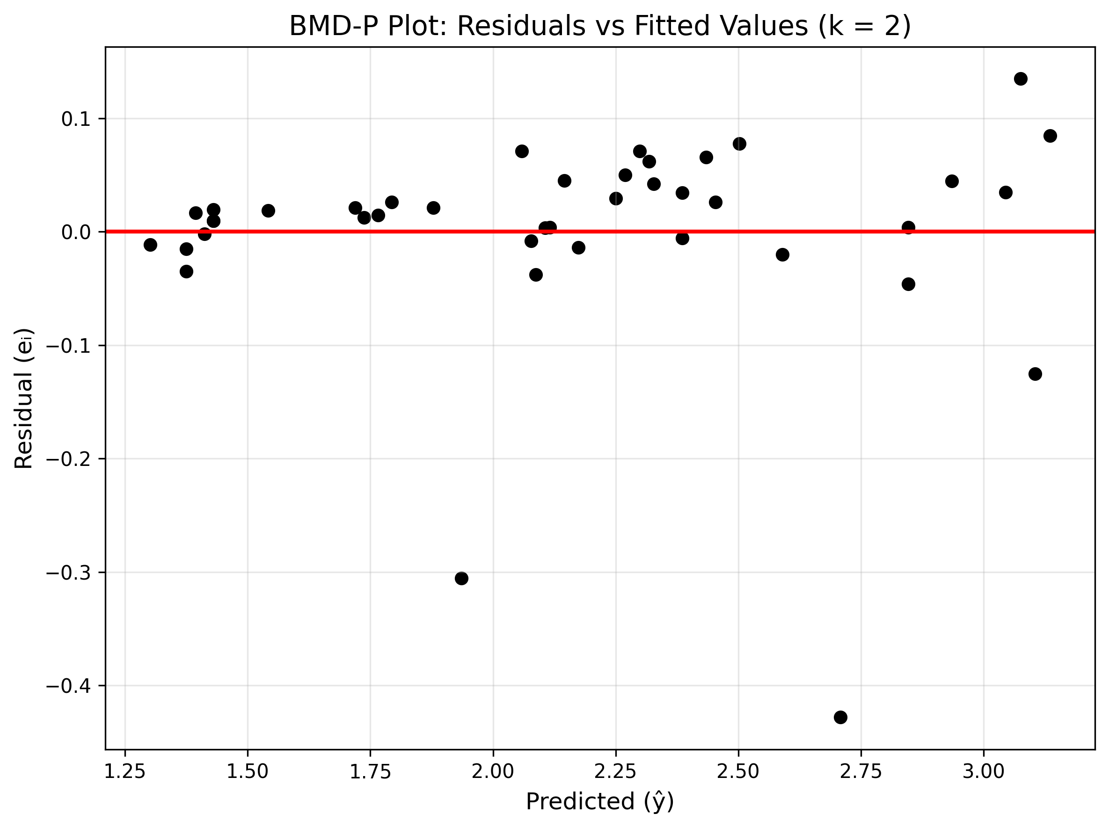
Fig 1. Plot (BMD-P) of residuals versus fitted values for the quadratic polynomial regression model

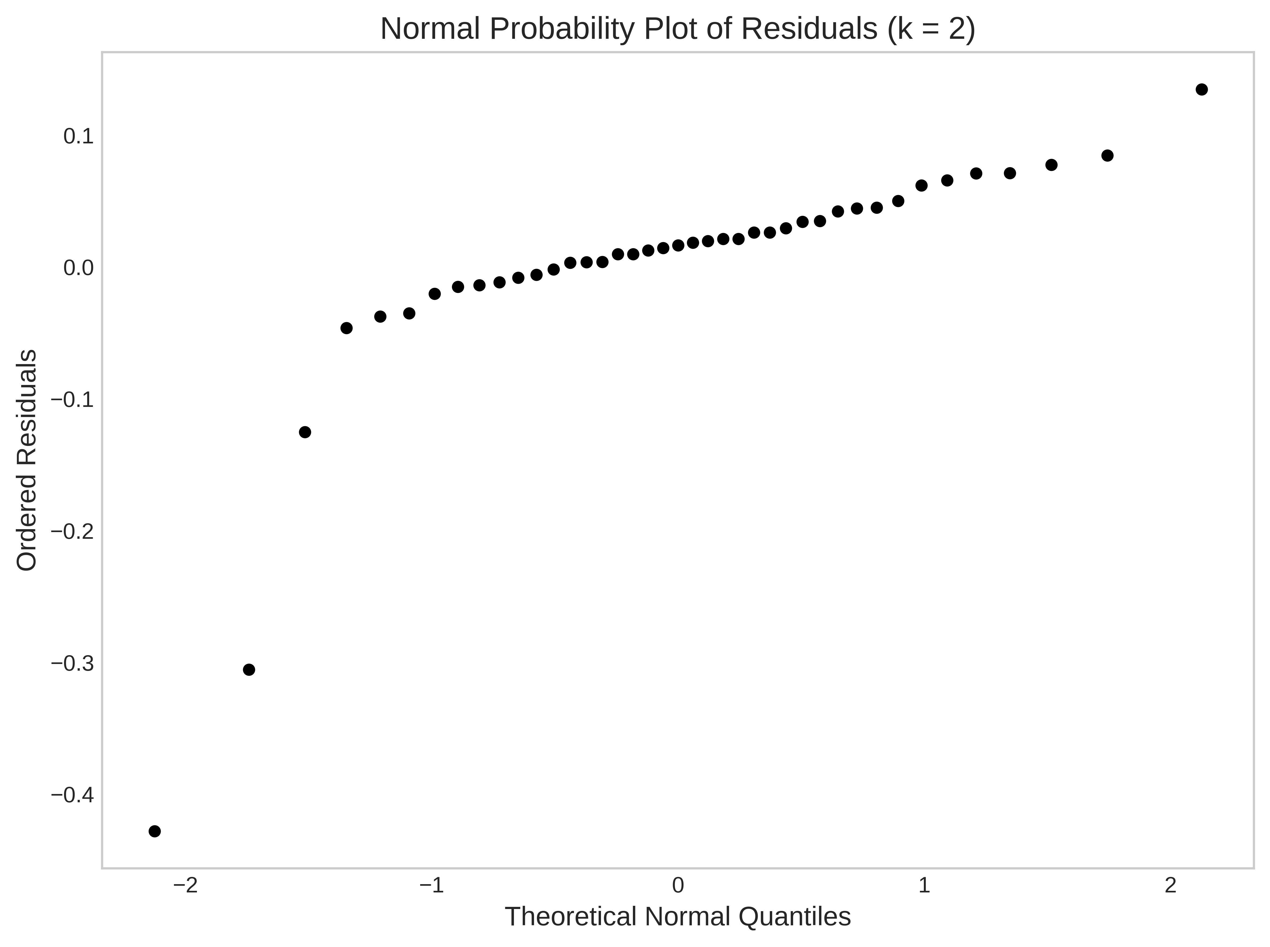
Fig 2. Normal probability plot (BMD-P) of the residuals

The cubic polynomial model (k=3) fits the observed data more closely than the quadratic model (k=2), The cub show fluctuations handkerchief in the data in a better manner, whereas the quadratic does not show the same performance. Hence the graph (Fig1.) supports their results that the cubic model provides superb performance.
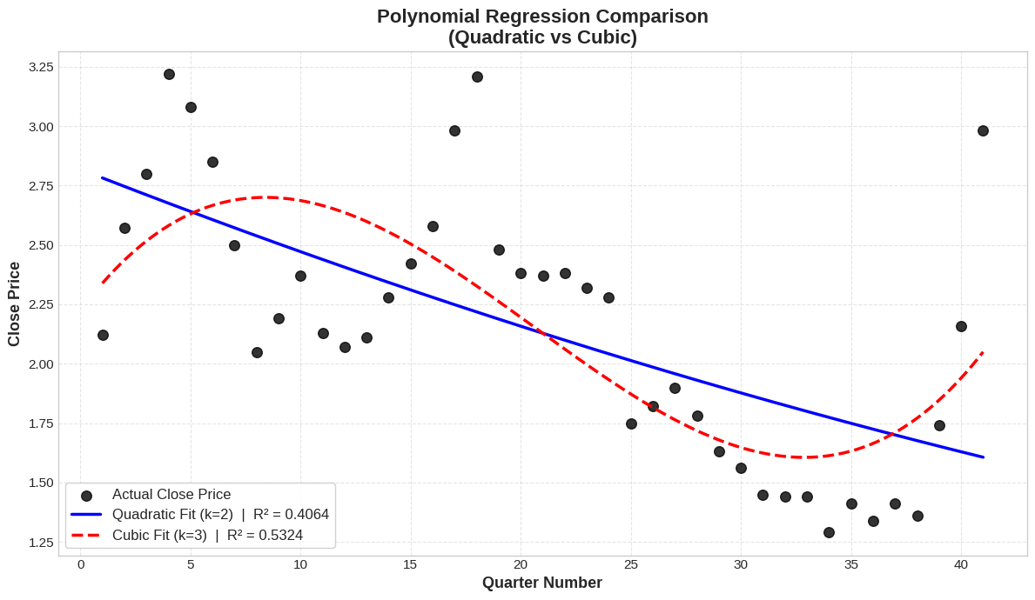
Fig 3. comparison of polynomial regression when k=2 & k=3

The results show that cubic Polynomial Regression model is better than the quadratic model across all metrics. The Cubic model gets a lower RMSE (0.373) to (0.421) and lower MAPE (14.170%) to (16.343%), indicating better predictive accuracy and reduce average forecasting error. The R² Value increases from 0.376 To 0.532. This shows a considerable increase the explanatory power. The Adjusted R² increases From 0.343 to 0.494, This confirms that there is improvement in the Model fit. Thus hold on the cubic model provides a better representation of the data pattern.
Table 6. ANOVA for the quadratic model
Source of Variation | DF | SS | MS | F
Regression | 2 | 6.307 | 2.102 | 11.756
Residual | 38 | 6.617 | 0.178
Total | 40 | 12.924

ŷ = 2.847677 + -0.037273x + 0.000196x²
Table 7. Test table when k=2
Significance Test
P-value | 0.00011
Significance level | 0.05
Decision | Reject H0

Table 8. ANOVA for the cubic model
Source of Variation | DF | SS | MS | F
Regression | 3 | 6.307 | 2.102 | 11.756
Residual | 37 | 6.617 | 0.178
Total | 40 | 12.924

ŷ = 2.151220P0(x) + -0.029392P1(x) + 0.000165P2(x) + 0.000150P3(x)

Table 9. Test table when k=3
Significance Test
P-value | 0.000002
Significance level | 0.05
Decision | Reject H0

Table 10. Orthogonal polynomial
Criteria | Quadratic | Cubic
RMSE | 0.421 | 0.373
MAPE | 16.343 | 14.170
R² | 0.376 | 0.532
Adjusted R² | 0.343 | 0.494

The cubic orthogonal polynomial regression model (k=3) Shows a closer relationship with the observed data than off the quadratic version. It helps show more complex curvature patterns, whereas quadratic model is smoother and less adaptable. This graphical comparison Shows that the statistical evidence of increasing the polynomial order helps improve the model’s performance.
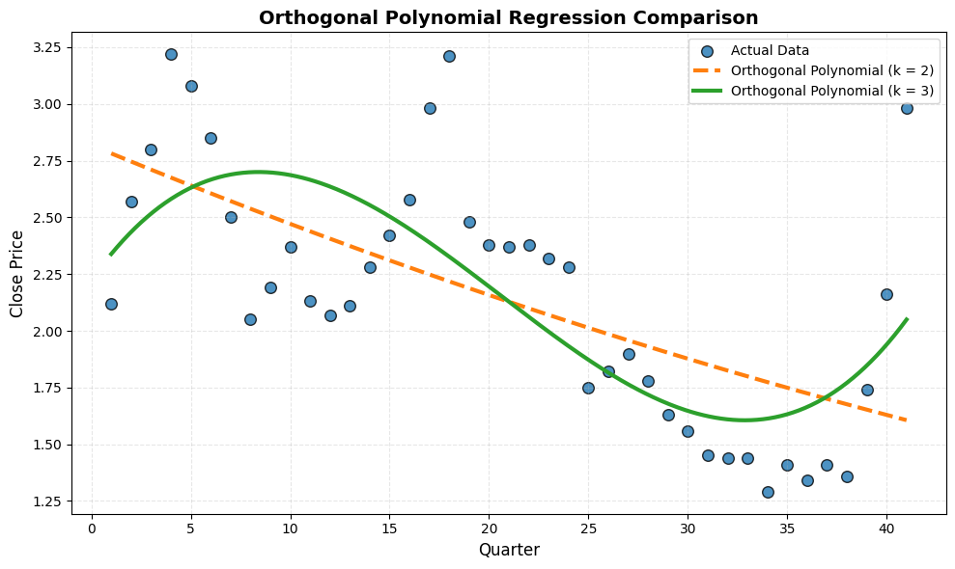
Fig 4. comparison of orthogonal polynomial regression when k=2 & k=3

The cubic orthogonal polynomial model is better than the quadratic Model in all criteria. It has lower RMSE(0.373) and MAPE(14.170) values and larger R² (0.532) and Adjusted R²(0.494) values In comparison to the quadratic model. The results show increasing the polynomial degree will make the model fit better. The equal value of performance metrics between standard and orthogonal polynomial regression shows that using orthogonal polynomial increases the numerical stability without changing predictive performance. Hence, The cubic orthogonal polynomial model gives a better and stable fit.

Table 11. ANOVA for the piecewise Polynomial
Source of Variation | DF | SS | MS | F
Regression | 6 | 8.794 | 1.759 | 17.86
Residual | 34 | 3.449 | 0.098
Total | 41 | 12.242

$$\overset{ˆ}{y}(x)=\left\{\begin{matrix}2.10+0.45x-0.030x^{2}+0.0012x^{3}, & x≤14 \\ -1.75+0.92x-0.041x^{2}+0.0015x^{3}, & 14<x≤21 \\ 3.60-0.38x+0.018x^{2}-0.0006x^{3}, & 21<x≤30 \\ -4.20+0.72x-0.022x^{2}+0.0004x^{3}, & x>30\end{matrix}\right.$$
Table 12. Test table
Significance Test
P-value | 0.000001
Significance level | 0.05
Decision | Reject H0

Table 13. Piecewise polynomial
Criteria | Quadratic | Cubic
RMSE | 0.301 | 0.262
MAPE | 10.880 | 8.820
R² | 0.695 | 0.768
Adjusted R² | 0.652 | 0.719

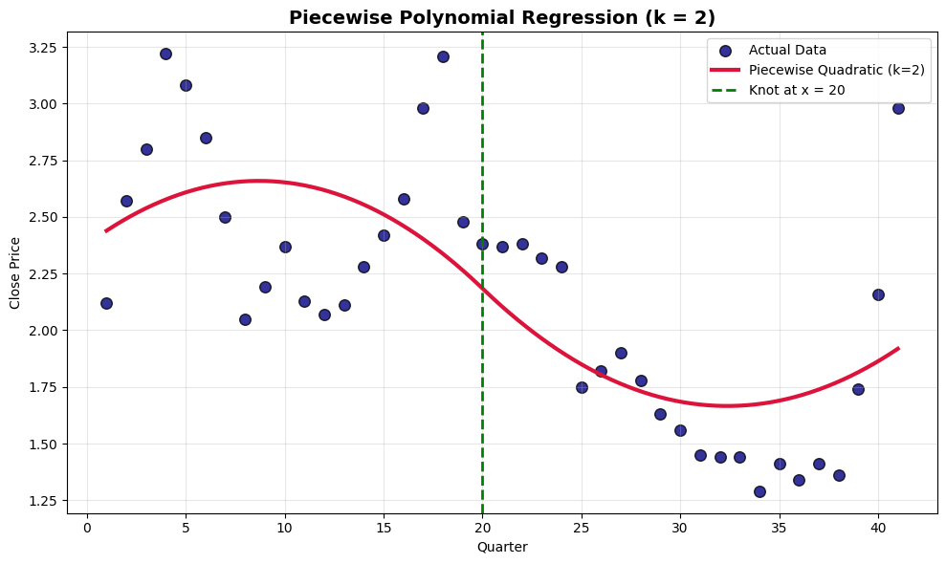
Fig 5. comparison of piecewise polynomial when k=2

The quadratic piecewise model Has higher flexibility compared to global quadratic regression; but it is less responsive to sharper Nonlinear patterns in comparison to the cubic piecewise. Small deviations unnoticed in regions of high curvature, Showing comparatively lower accuracy.

The cubic piecewise polynomial Model follows the footsteps of local data trends, Hence showing increased flexibility and less deviation from the observed values. Better Transitions between segments suggest the effective modelling of nonlinear structural changes. Hence the graph (Fig 2.) sides with a good statistical performance of the piecewise model.
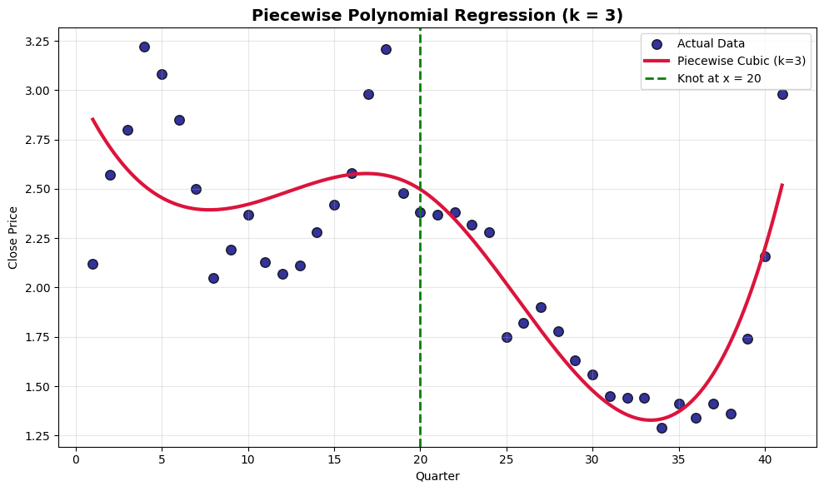
Fig 6. comparison of piecewise polynomial when k=3

Piecewise polynomial regression considerably improves the performance of the model compared to global polynomial models. The cubic piecewise model gets the lowest RMSE (0.262) and MAPE (8.82%) and the highest R² (0.768) and Adjusted R² (0.719), Making it the best model. The Cubic spline also has good performance but it’s comparatively lower in performance compared to the cubic piecewise model. The quadratic piecewise model shows that it’s better than global polynomials but not as good of a performance as of the cubic model. These findings show that the structural flexibility through segmentation highly increases the predictive accuracy.

Table 14. Summary Statistics for the cubic spline model of the AEY Quarterly data
Source of Variation | df | SS | MS | F
Regression | 6 | 9.575 | 1.595 | 20.33
Residual | 34 | 2.668 | 0.078
Total | 40 | 12.243

$$ŷ = 0.608 + 1.045x + 0.001x^{2} + 1.046x^{3} - 1.168{\left(x - ξ_{1}\right)}^{3} + 0.515{\left(x - ξ_{2}\right)}_{+}^{3} + 0.900{\left(x - ξ_{3}\right)}_{+}^{3}$$
Table 15. Cubic Spline Results
Criteria | Knot = 2 | Knot = 3
RMSE | 0.267 | 0.262
MAPE | 9.79 | 9.33
R² | 0.772 | 0.782

Table 16. Cubic Spline Beta comparison
Parameter | Estimate | Standard Error | T-value | P-value
$$β_{00}$$ | 0.608 | 0.205 | 2.96 | 0.0056
$$β_{01}$$ | 1.045 | 0.306 | 3.41 | 0.0017
$$β_{02}$$ | 0.001 | 0.275 | 0 | 1.0000
$$β_{03}$$ | 1.046 | 0.253 | 4.13 | 0.0002
$$β_{1}$$ | -1.168 | 0.304 | -3.85 | 0.0005
$$β_{2}$$ | 0.515 | 0.267 | -1.93 | 0.0620
$$β_{3}$$ | 0.900 | 0.221 | 4.06 | 0.0003

Table 17. Summary Statistics for the natural cubic spline model of the AEY Quarterly data
Source of Variation | df | SS | MS | F
Regression | 6 | 10.253 | 1.708 | 17.306
Residual | 34 | 3.456 | 0.098
Total | 40 | 13.709

$$ŷ = ​1.929 + 0.889 N_{1}\left(x\right) + 0.433 N_{2}\left(x\right) + 0.610 N_{3}\left(x\right) + 0.194 N_{4}\left(x\right) - 0.676 N_{5}\left(x\right) + 0.478 N_{6}\left(x\right)$$

Table 18. Natural Cubic spline Results
Criteria | Knot = 2 | Knot = 3
RMSE | 0.436 | 0.300
MAPE | 16.78 | 10.69
R² | 0.395 | 0.713

Table 19. Natural Cubic Spline Beta comparison
Parameter | Estimate | Standard Error | T-value | P- value
$$β_{00}$$ | 1.929 | 0.047 | 40.784 | <0.0001
$$β_{01}$$ | 0.889 | 0.179 | 4.958 | <0.0001
$$β_{02}$$ | 0.433 | 0.121 | 3.556 | 0.0010
$$β_{03}$$ | 0.610 | 0.114 | 5.347 | <0.0001
$$β_{1}$$ | 0.194 | 0.114 | 1.701 | 0.0980
$$β_{2}$$ | -0.676 | 0.121 | -5.549 | <0.0001
$$β_{3}$$ | 0.478 | 0.179 | 2.669 | 0.0115

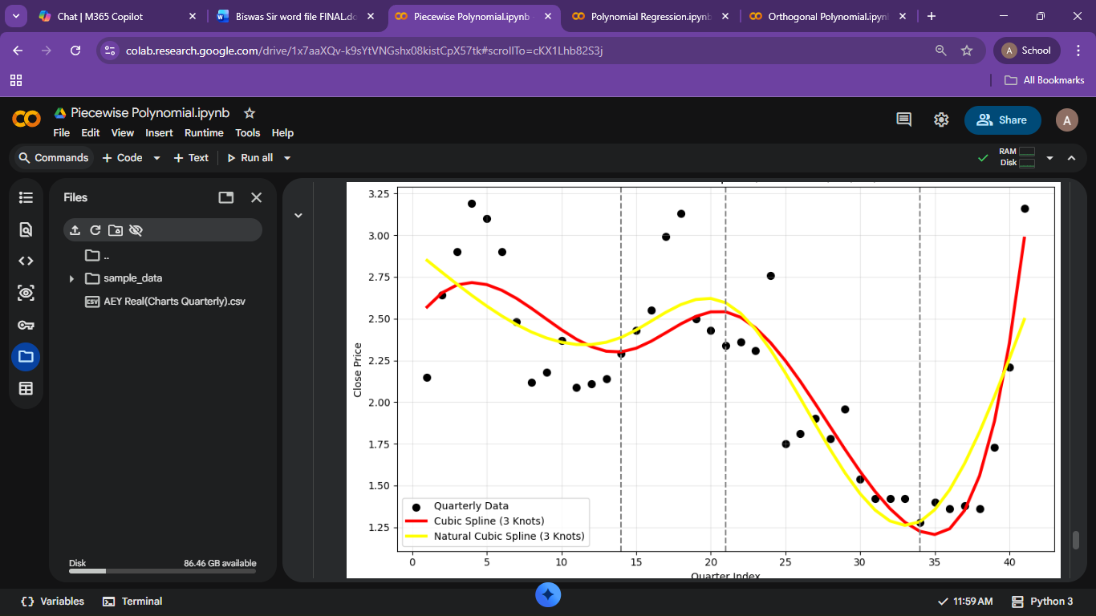
Fig 7. A cubic spline and a natural cubic spline, with three knots, fit to a subset of AEY Quarterly Data.

LKCO Data
Table 20. ANOVA for the quadratic model
Source of Variation | DF | SS | MS | F
Regression | 2 | 3562.820 | 1781.410 | 6.170
Residual | 15 | 4330.284 | 288.685
Total | 17 | 7893.104

$$ŷ=25.965+10.591-0.472x^{2}$$
Table 21. Test table when k=2
Significance Test
P-value | 0.011
Significance level | 0.05
Decision | Reject H0

Table 22. ANOVA for the cubic model
Source of Variation | DF | SS | MS | F
Regression | 3 | 6369.23 | 2123.241 | 19.512
Residual | 14 | 1523.388 | 108.812
Total | 17 | 7893.104

$$ŷ=72.171-15.175x+2.827x^{2}-0.115x^{3}$$
Table 23. Test table when k=2
Significance Test
P-value | <0.00001
Significance level | 0.05
Decision | Reject H0

Table 24. Piecewise polynomial
Criteria | Quadratic | Cubic
RMSE | 15.510 | 9.199
MAPE | 18.873 | 9.199
R² | 0.451 | 0.807
Adjusted R² | 0.378 | 0.765

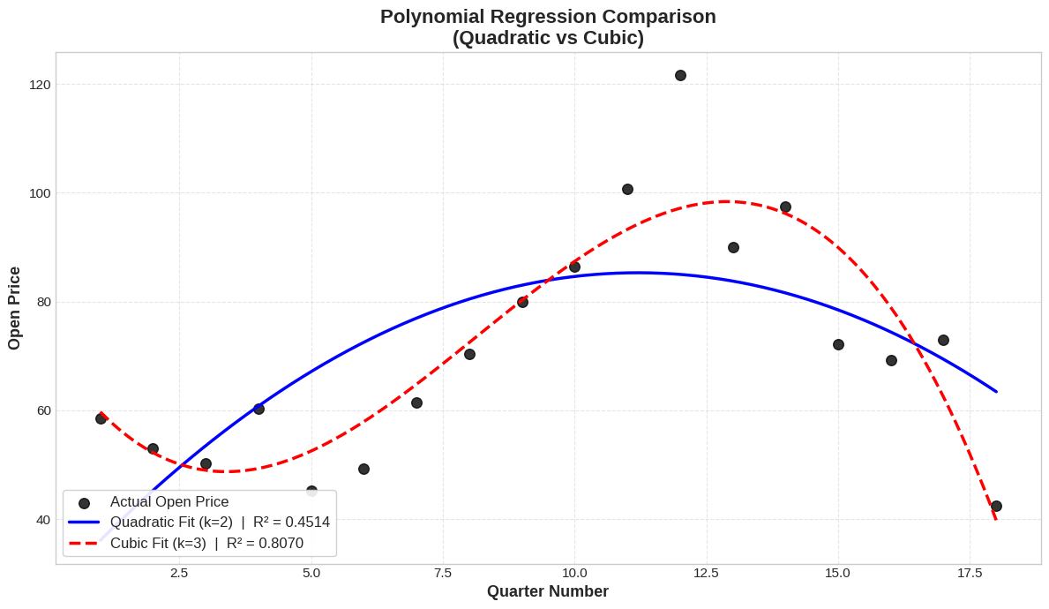
Fig 8. comparison of polynomial regression when k=2 & k=3

The cubic polynomial model (k=3) Gives a better in comparison to the quadratic model (k=2), as shown by the higher R² value. It shows the nonlinear variations and changes more effectively, especially when there is rapid increase or decline in open prices. On the contrary, the quadratic model is too smooth with trends and does not represent local variability, showing that higher Order polynomials increase flexibility and model accuracy. (Fig 8.)

Table 25. ANOVA for the quadratic model
Source of Variation | DF | SS | MS | F
Regression | 2 | 3562.820 | 1781.410 | 6.170
Residual | 15 | 4330.284 | 288.685
Total | 17 | 7893.104

$$ŷ = 25.965 + 10.591- 0472x²$$
Table 26. Test table when k=2
Significance Test
P-value | <0.0001
Significance level | 0.05
Decision | Reject H0

Table 27. ANOVA for the cubic model
Source of Variation | DF | SS | MS | F
Regression | 3 | 6369.723 | 2123.241 | 51.569
Residual | 37 | 1523.388 | 41.172
Total | 40 | 7893.104

$$ŷ = 71.182P_{0}\left(x\right)+1.607P_{1}\left(x\right)- 0.472P_{2}\left(x\right)- 0.115P_{3}(x)$$

Table 28. Test table when k=3
Significance Test
P-value | <0.0001
Significance level | 0.05
Decision | Reject H0

Table 29. Orthogonal polynomial
Criteria | Quadratic | Cubic
RMSE | 15.510 | 9.199
MAPE | 18.873 | 9.199
R² | 0.451 | 0.806
Adjusted R² | 0.378 | 0765

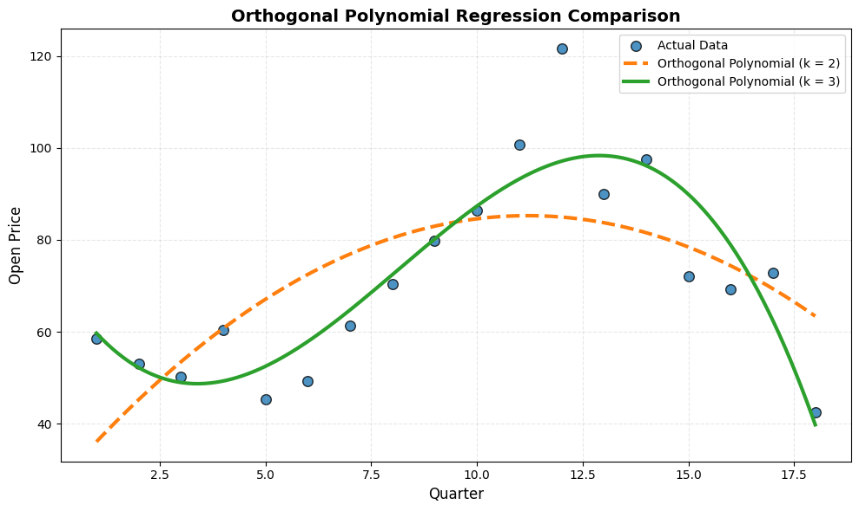
Fig 9. comparison of orthogonal polynomial regression when k=2 & k=3
Orthogonal polynomial regression with degree (k=3) provides justice to the underlying data better than (k=2) by taking into consideration changes in curvature across quarters. The cubic orthogonal model follows the shown peaks and downturns while being stable numerically. The quadratic model only shows a general trend and misses out on deviations, hence showing the advantage of orthogonal high-degree terms in lowering multicollinearity and increasing model interpretability. ( Fig 9.)

Table 30. ANOVA for the piecewise Polynomial
Source of Variation | DF | SS | MS | F
Regression | 3 | 6700.178 | 2233.392 | 26.210
Residual | 14 | 1192.925 | 85.209
Total | 17 | 7893.104

$$\overset{ˆ}{y}=9.267+0.676t-0.627t^{2}+1.081{(t-3)}_{+}^{2}$$
Table 31. Test table
Significance Test
P-value | <0.00001
Significance level | 0.05
Decision | Reject H0

Table 33. Piecewise polynomial
Criteria | Quadratic | Cubic
RMSE | 1.172 | 0.837
MAPE | 27.446 | 34.464
R² | 0.889 | 0.943
Adjusted R² | 0.723 | 0.718

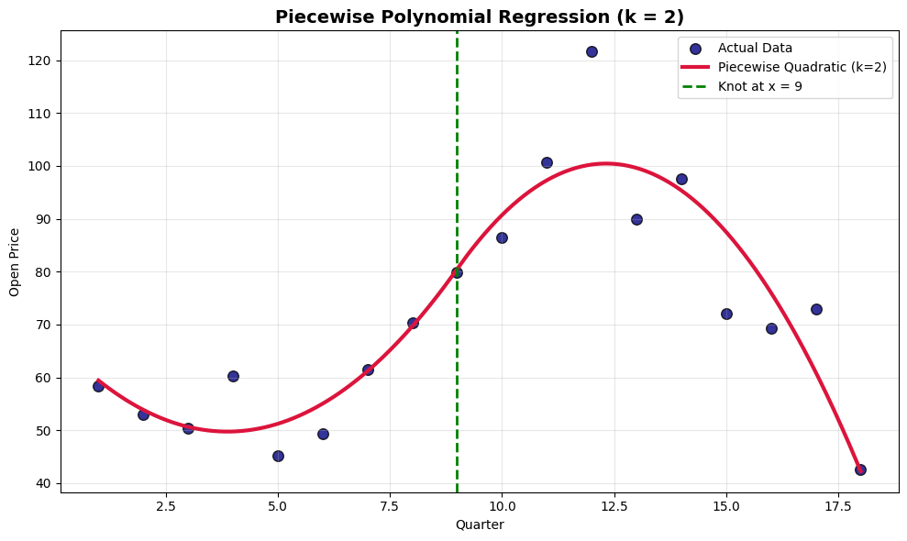
Fig 10. comparison of piecewise polynomial when k=2

The piecewise quadratic regression model with a knot at quarter 9 divides the dataset into 2, it successfully characterizes changes in the price. It shows a gradual increase before the knot and a decrease after it, this helps in increasing local fit in comparison to a single polynomial. But sometimes extreme variations are not accounted for, this shows that quadratic flexibility may not be sufficient for sharp nonlinear patterns. ( Fig 10.)
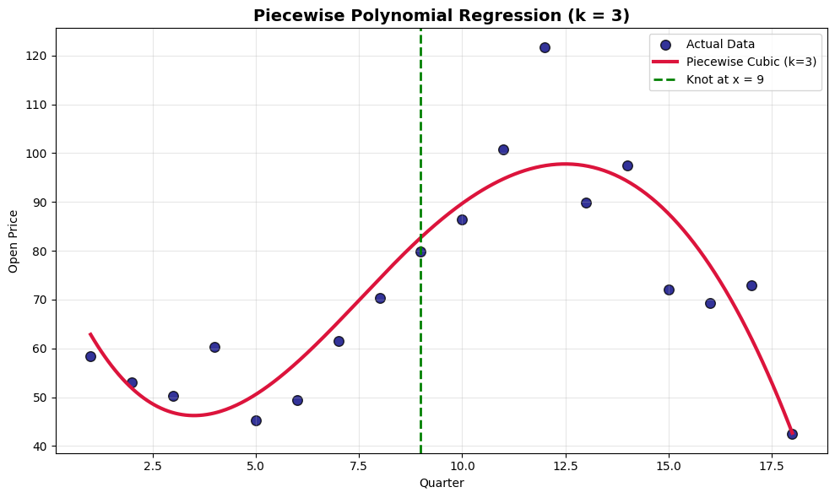
Fig 11. comparison of piecewise polynomial when k=3
Piecewise cubic regression model shows the best flexible representation in comparison to the models under consideration; it correctly tracks both increase and decrease with respect to the knot at quarter 9. Higher order polynomial shows changes and variations in a better manner, giving a smooth and responsive fit. This shows that using piecewise segmentation with cubic flexibility increases prediction performance and shows adaptability to complex trends. (Fig 11.)

References
Chow, G. C. (1960). Tests of equality between sets of coefficients in two linear regressions. Econometrica, 28(3), 591–605. https://doi.org/10.2307/1910133
Draper, N. R., & Smith, H. (1998). Applied regression analysis (3rd ed.). John Wiley & Sons.
Gauss, C. F. (1809). Theoria motus corporum coelestium in sectionibus conicis solem ambientium. Perthes et Besser.
Galton, F. (1886). Regression towards mediocrity in hereditary stature. The Journal of the Anthropological Institute of Great Britain and Ireland, 15, 246–263.
Legendre, A. M. (1805). Nouvelles méthodes pour la détermination des orbites des comètes. F. Didot.
Montgomery, D. C., Peck, E. A., & Vining, G. G. (2012). Introduction to linear regression analysis (5th ed.). John Wiley & Sons.
Quandt, R. E. (1960). Tests of the hypothesis that a linear regression system obeys two separate regimes. Journal of the American Statistical Association, 55(290), 324–330. https://doi.org/10.1080/01621459.1960.10482067
Tibshirani, R. (1996). Regression shrinkage and selection via the LASSO. Journal of the Royal Statistical Society: Series B, 58(1), 267–288.

Applications of Polynomial Regression
- It is used when the relationship between variables is not straight but curved.
- In many real-life situations changes do not happen in a constant way. Polynomial regression helps us handle such cases where a simple straight-line model does not fit the data properly.
- Economics and business - Profit or demand may increase at first and then slow down after a certain point. Polynomial regression helps in understanding such patterns and in making better predictions instead of forcing a straight line where it clearly does not belong.
- Science & Engineering - Many physical processes follow curved patterns, such as stress us strain, temperature us time or distance us speed. Polynomial regression helps engineers and scientists model these relationships more accurately and study how one variable reacts to changes in another.
- Data analysis & forecasting - Polynomial regression is useful when trends rise and fall over time. Sales growth population changes often do not increase at a fixed rate. A polynomial model can capture these ups and downs better than a linear model.

